Zadání práce z konverzace v angličtině na týden 16. 3. – 20. 3. 2020

Skupina: 7.A
Vyučující: Mgr. Dobrodějová Eva

- Pracovní list strana 87
  - Str 87 / cv. 6 – doplňte do vět slova z nabídky
  - Str 87 /cv. 8 – Dejte činnosti do správného pořadí.

- Počitatelná a nepočitatelná podstatná jména
  - Postupujte dle zadání u jednotlivých cvičení

Správné odpovědi sepište a v pátek 20. 3. pošlete na email eva.dobrodejova@mzs-vb.cz nebo podepsané vhoďte do schránky u vstupu do školy.

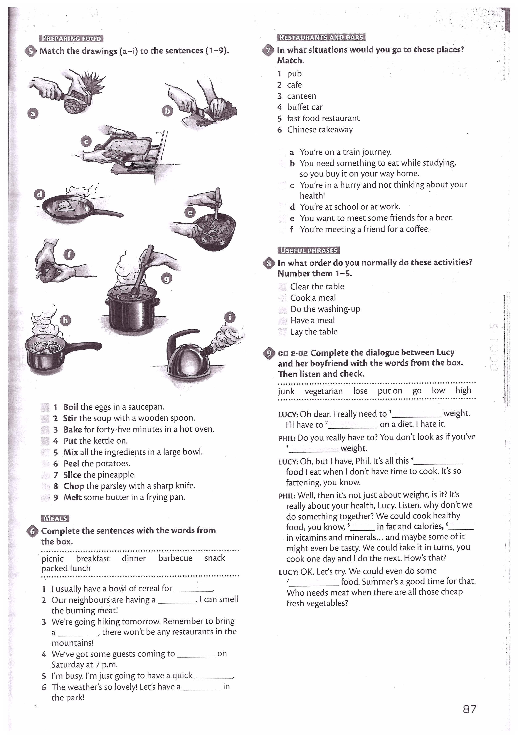

Decide whether the following nouns are countable or uncountable.
apple bowl water cup oil salt bottle butter glass plate knife fork sugar
coffee milk juice spoon ham tea mug loaf jam bread cereal rice cheese
COUNTABLE | UNCOUNTABLE

Use the tables below to make sentences.
We have  Do we have | some  any | tea  coffee  butter  bread  cereal  plates | .  ? |  | We have  Do we have | a  an | fork  loaf of bread  cup of tea  mug of coffee  plate  apple | .  ?

1)___________________________________________________________________?
2) ___________________________________________________________________?
3) ___________________________________________________________________?
4) ___________________________________________________________________?

Fill in the gaps using a, an, some or any, then practise the conversation with your partner.
A: Is there ________ food in the fridge?
B: Wait ________ minute, I will take a look.
B: There is only ________ cheese and ________ apple. We will have to go to the shop.
A: What do you want to buy? I will make a list.
B: Well, I would like to get ________ bread, ________ jam, ________ tea and ________ cereal.
A: OK, ________ loaf of bread, ________ jam, ________ tea and ________ cereal. Anything else?
B: Hmm, do we need ________ sugar or salt?
A: No, I think we don’t need ________.
B: Oh, and we should get ________ bottle of milk, we do not have ________ milk for the cereal.
A: Of course! And we also need to buy ________ new knife. Ours is broken.
B: I thought you bought ________ new knife last week.
A: No, I bought ________ spoons last week. We didn’t have ________ spoons for the party.
B: OK, I think that’s all. Are you ready to go?
A: Yes, let’s go.

