
Předmět: Anglický jazyk
AJ
DOSTÁL
8th

Týden: 9. 11. - 13. 11. (5th)
Učitel: Dostál
Email: ondrej.dostal@mzs-vb.cz

Dobrý den, níže zasílám zadání prací, v případě nepochopení neváhejte a kontaktujte mne. Budeme se vídat v rámci video lekcí a to 2-krát týdně. Pokud to nezazní jinak, vypracované úkoly Vás poprosím zaslat na ondrej.dostal@mzs-vb.cz vždy do následujícího pátku. Pokud máte možnost tisknout – vytiskni a vyplň – pokud nelze tisknout – opsat do sešitu.
Termíny schůzek na TEAMS : pondělí – 8,30 – 9.00
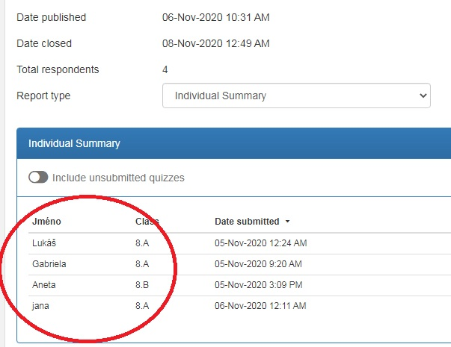
středa – 8,30 – 9,00
Dobrý den, myslím, že obrázek bude nejvíce vypovídající.
Na co se díváte, je účast na online testu (4 žáci), kdo nepsal, byl
automaticky hodnocen nedostatečnou. Tento týden
proběhne další online test. Proto Vám doporučuji
na hodinách poslouchat, kde a kdy test proběhne.

- Čtení – The Little Princ – tvým úkolem je přečíst úryvek a do sešitu nejméňe 7-mi větami popsat, o čem si četl(a) – anglicky

The first night, I sleep on the sand. I am a thousand miles from a land with people. I think that no people are around me. So I am shocked when somebody speaks to me in the morning.
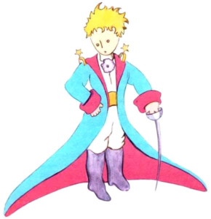
I hear these words, “Please, draw me a sheep.”
“What?”
“Draw me a sheep!”
I jump up. I look around. And I see a little man.
This is the picture of the little man.

My picture is not very good. The original model is better. It is not my mistake. I know how to draw only two pictures. They are pictures of a snake from the outside and a snake from the inside.
I look at this little man. I am really surprised. Don’t forget that I am a thousand miles from a land with people. Something is very interesting. This little man is not tired. He is not hungry. He is not thirsty. He is not scared. He doesn’t look lost in the middle of the desert, a thousand miles from a land with people.
The little man says, very slowly, “Please draw me a sheep.”
It is all very strange to me. I am a thousand miles from a land with people. I am in danger of death. But I take a pen and paper from my pocket. I want to draw a picture. Then I remember that I know only geography, history, maths and grammar. And I tell the little man that I don’t know how to draw.
He says, “It is OK. Draw me a sheep.” But I don’t know how to draw a sheep. So I draw him a picture which I am able to draw. It is a big snake from the outside. And I am shocked when the little man says, “No, I don’t want an elephant inside a big snake. A big snake is a very dangerous animal. And an elephant is very big for me. Where I live, everything is very small. I need a sheep. Draw me a sheep.”
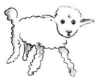
So I make this picture.

The little man looks at the picture. Then he says, “No. This sheep is ill. Make me another sheep.”
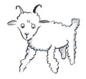
I draw another picture.

My friend smiles at me, “You must see it too. This is not a sheep. It is a ram. It has horns.”
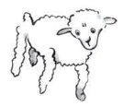
So I make another picture.

But this picture also isn’t good.
“This sheep is old. I want a sheep which can live a long time.”
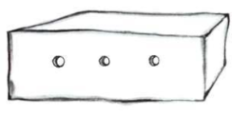
It is not easy for me. I don’t have time for this. I must start my work on the plane. So I draw this picture.

And I say, “This is a box. The sheep is inside.”
I am surprised when I see the light in his face, “This is what I want! Do you think that this sheep needs a lot of grass?”
“Why?”
“Because where I live, everything is very small.”
“I think that there is enough grass for the sheep. This is a very small sheep.”
The little man looks at the picture. And he says, “The sheep is not very small. It is a very nice sheep.”
This is my first day with the little prince.

- Online test na slovní zásobu s učebnice – zelený box (str.22)
https://www.flexiquiz.com/SC/N/2b46eb33-e710-472e-b3d5-a4f56425dc56
- Injuries / accidents and First AID (str. 23)
  - Práce ve středeční hodině s učebnicí
  - Slovní zásoba
  - Zadání práce
- Napiš do sešitu krátký příběh o tvém jakémkoliv zranění. Použij minulý čas!!!
  - Platí až po středeční výuce (bod č. 4)

