
Fill in the gaps with a word from the box. Only use each word once

selfish bad-tempered tough crafty sensitive sensible strict
trustworthy dull shy mean reliable stubborn silly
nice cheerful sympathetic clumsy loyal gentle

- Janet is incredibly ………………………… . She always arrives on time and does her job well.
- It’s impossible to say anything to him. One word and he starts crying. He is so ................................ !.
- I wonder why he is so ................................. . He has got lots of money but he hates spending it.
- When she was a child, her parents were incredibly .................... . Whenever she did the smallest thing wrong, they would send her to bed.
- Ann is such a .................................. girl. She is always laughing and smiling.
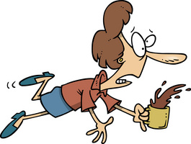
- Come on, Maria!. You can’t go on a country walk wearing high heels. Do be ...................................... for once.
- I’ll give you a lift home if you’re .................................. to me.
- She was so ........................................ and understanding. When I told her my problems, I immediately felt better afterwards.
- In westerns, the hero is always ................................ . He always beats his enemies and can put up with any hardship.
- That’s the second cup you’ve broken this week. Why do you have to be so ............................... ? .
- I think he is an extremely ................................ boy. He laughs at stupid things and never concentrates in class.

- Children are often really ................................... . They hide behind their mothers when guests come.
- Don’t be so .................................., Cathy. You’ve got to learn to share things with other children
- She is 100% .............................................. . I’d leave my money, car, anything, for her to look after.
- When I broke my leg, the nurse was so ........................................... that she hardly hurt me at all.
- Why do you get angry all the time?. You are so ............................................
- Bob is my best friend. He remained ........................................... through all my problems.
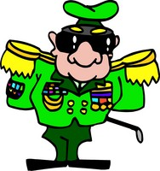
- He is such a ....................................... person with his boring little job and his boring little life.
- He is terribly .......................................... . Once he has made up his mind, it is impossible to get him to change it even if it’s obvious that he is wrong.
- The general was really .................................................. . Just when the enemy thought it had won the battle, he played his best card.

KEY

1. reliable 11. silly
2. sensitive 12. shy
3. mean 13. selfish
4. strict 14. trustworthy
5. cheerful 15. gentle
6. sensible 16. bad-tempered
7. nice 17. loyal
8. sympathetic 18. dull
9. tough 19. stubborn
10. clumsy 20. crafty

